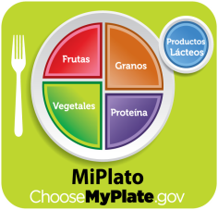 Campus Wellness Plan

Normandy Crossing Elementary

2016-2017

Federal public law (PL108.265 SEC.204) states that all schools must develop a local wellness policy that involves parents,students,representative from school food authority,school board,school administrator and the public, the local education authority (LEA) will establish a plan for measuring implementation of the local wellness policy.

Mission Statement: Galena park I.S.D. shall prepare,adopt, and implement a comprehensive plan to encourage healthy eating and physical activity in order to prepare students to become healthy productive citizens and lifelong learners.

Nutrition Education:

* Promote healthy eating and exercise using bulletin boards and place them in school hallways.
* Videos about importance of healthy eating and physical activity will be shown to students.
* Faculty and staff will encourage students to eat healthy snacks.
* Classroom celebrations shall be limited to two parties per school year and will be held during last hour of the school day.
* P.E coach will teach students health and wellness during P.E class.

Physical Education:

* Physical education teacher will continue to incorporate daily moderate to vigorous activities that will help enhance and develop healthy related fitness.
* Physical activity will not be used as a punishment(e.g running laps or pushups).
* Promote at least 60 min. a day of physical activity among students, faculty and staff.

Nutrition Standards:

* Review school lunch menu each month.
* Encourage faculty and staff to be a model of healthy eating to students .
* Faculty and staff will promote hand washing and encourage safe eating practices such as no sharing of foods or drinks.

Other school related activities:

* Provide information to parents during school events e.g. PTA about importance of healthy eating and physical activity.

Campus wellness team includes the following required personnel: P.E. coach, cafeteria manager, teacher, nurse, administrator ,parents are welcome to be a part of this committee.